

Name :- Nigam yadav Sheet No. :- 1

Roll No:- PUR078BCT053 Checked By:-

**LAB SHEET NO.1[To be familiar with C – programming]**

1.Write a program to print hello world.

#include<stdio.h>

int main()

{

printf("Hello world!");

return 0;

}

Output

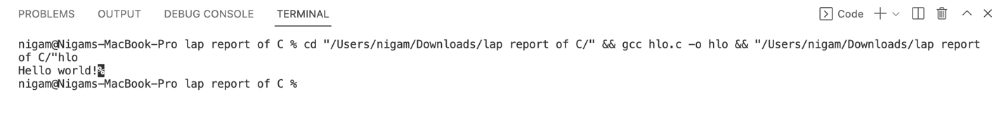

2. Write a program to print your name, roll number and address.

#include<stdio.h>

int main()

{

printf("My name is Nigam Yadav\n");

printf("My roll number is PUR078BCT053\n");

printf("I live in Dharan-8,Langali chowk\n");

return 0;

}

Output

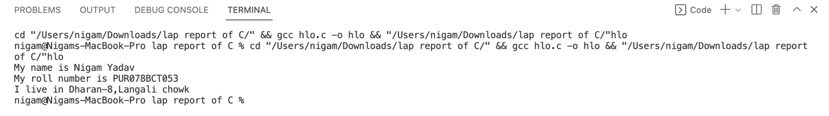

3. Write a program to add two integer variables and print sum.

#include<stdio.h>

int main()

{

int a,b,sum;

printf("Enter the value of a and b:");

scanf("%d%d",&a,&b);

sum=a+b;

printf("The sum is = %d",sum);

return 0;

}

Output

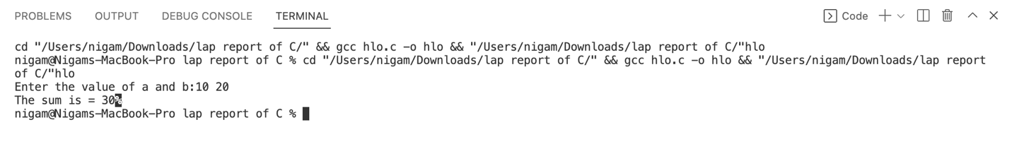

4. Write a program to multiply two integer variables and print product.

#include<stdio.h>

int main()

{

int a,b,product;

printf("Enter the value of a and b:");

scanf("%d%d",&a,&b);

product=a*b;

printf("The product is = %d",product);

return 0;

}

Output

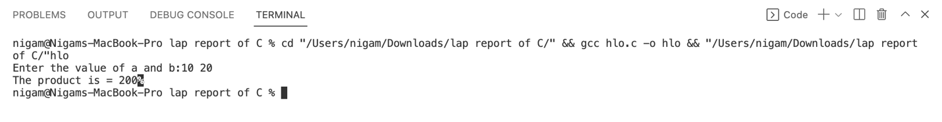

5. Write a program to calculate and display simple interest.

#include<stdio.h>

int main()

{

int P,T,R,SI;

printf("Enter the value of P,T and R:");

scanf("%d%d%d",&P,&T,&R);

SI=(P*T*R)/100;

printf("The simple interest is = %d",SI);

return 0;

}

Output

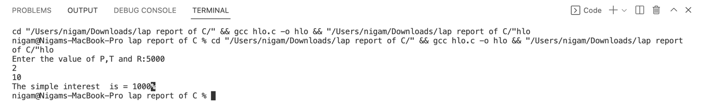

6. Write a program to calculate the area of circle.

#include<stdio.h>

int main()

{

float r,Area,pi= 3.1415;

printf("Enter the radius of the circle:");

scanf("%f",&r);

Area =pi*r*r;

printf("Area of a circle = %f",Area);

return 0;

}

Output

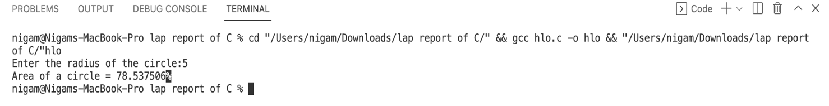



Name :- Nigam yadav Sheet No. :- 2

Roll No:- PUR078BCT053 Checked By:-

**LAB SHEET NO.2[To be familiar with Data types, Constants, Operators and Expressions]**

1.Write a program to declare integer, float and character variable. Initialize them with certain value and print those values. Also display the size of variables.

#include<stdio.h>

int main()

{

int a=10;

float b=4.0;

char star='*';

printf("the value of a = %d and the size of a is %lu\n",a,sizeof(a));

printf("the value of b = %f and the size of b is %lu\n",b,sizeof(b));

printf("star is %c and the size of star is %lu",star,sizeof(star));

}

Output

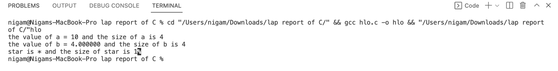

2. Write a program to swap the value of the variable with and without using third variable.

With using third variable

//swapping the values of two variables with using third variable

#include<stdio.h>

int main()

{

int a,b,temp;

printf("Enter the value of a and b:");

scanf("%d%d",&a,&b);

temp=a;

a=b;

b=temp;

printf("After swapping a=%d and b=%d",a,b);

return 0;

}

Output

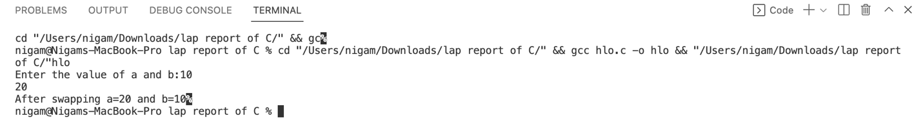

Without using third variable

#include<stdio.h>

int main()

{

int a=10, b=20;

printf("Before swap a=%d b=%d",a,b);

a=a+b;

b=a-b;

a=a-b;

printf("\nAfter swap a=%d b=%d",a,b);

return 0;

}

Output

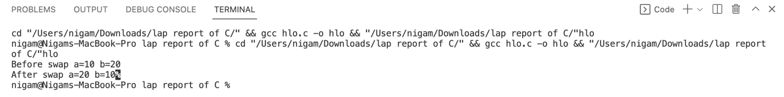

3. Write a program to calculate the area and volume of a cylinder using pre-processor directive for the value of Pi.

#include<stdio.h>

#define Pi 3.1415

int main()

{

float r,h,area,volume;

printf("Enter the value of r anf h:");

scanf("%f%f",&r,&h);

area=2*Pi*r*(r+h);

printf("Area of cylinder = %f",area);

volume=Pi*r*r*h;

printf("Volume of cylinder = %f",volume);

return 0;

}

Output

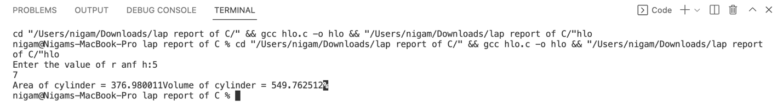

4. Write a program to input two numbers from user and display the minimum using conditional operator.

#include<stdio.h>

int main()

{

int a,b,minimum;

printf("Enter the value of a and b:");

scanf("%d%d",&a,&b);

minimum=(a<b)?a:b;

printf("the minimum value is %d",minimum);

return 0;

}

Output

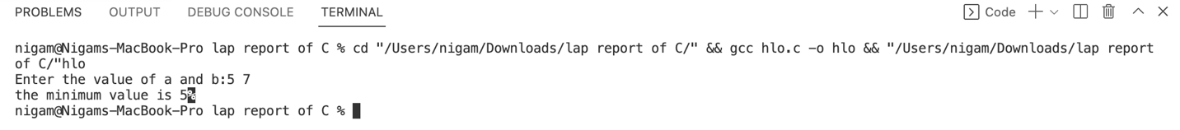

5. Write a program to display whether a number is odd or even using conditional operator.

#include<stdio.h>

int main()

{

int N,X;

printf("Enter the value of N:");

scanf("%d",&N);

X=N%2;

if(X==0)

{

printf("N is a even number.");

}

else

{

printf("N is a odd number.");

}

return 0;

}

Output

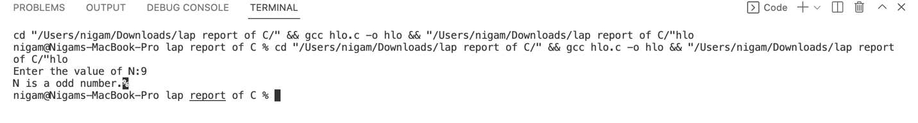

6. What are the output of the following programs:

#include<stdio.h>

int main()

{

int a =5, b = 9;

printf(“a = %d, b = %d\n”, a, b);

printf(“a&b = %d\n”, a & b);

printf(“a|b = %d\n”, a | b);

printf(“a^b = %d\n”, a^b);

printf(“~a = %d\n”, ~a);

printf(“(b<<2) + (a<<1) = %d\n”, (b<<2) +(a<<1));

printf(“(b>>1) + (a>>1) = %d\n”, (b>>1) +(a>>1));

return 0;

}

Output

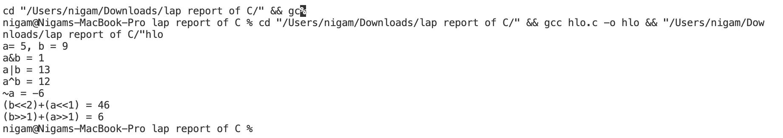

**CONCLUSION:-**

In this lab report, I become familiar to C-programming. I learn about using simple output and input function. I also learn about using instruction and operator like using ternary operator and conditional operators. I also learn to find logical and syntax error.